**Database Final Project**

**Raj Deliwala & Momen Emeesh**

**12/12/2015**

**Professor Aydin**

**Highline University Mentor Program Database**

**Data Model**

**Screenshot of Part I Erd**

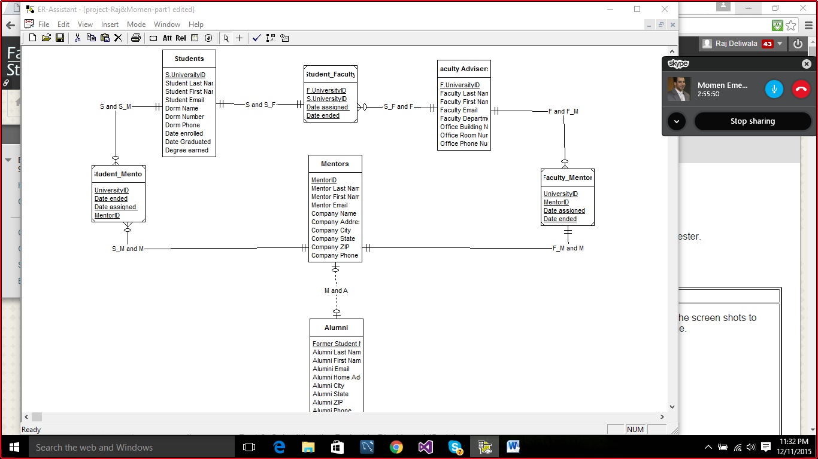

**Database Design**

**Screenshot Part II, Normalization steps, Property Tables, Integrity Statements, and Business Rules**

**Screenshot Part II :**

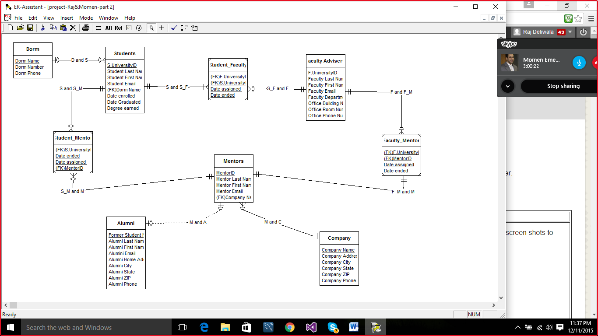

**Normalization steps:**

* All candidate keys have been identified and data looked normalized, there was no redundancy in any of the tables that needed normalization.
* We branched off STUDENTS table and took DORM out so our diagram could look neat and organized, setting DormName as a (PK) in DORM and (FK) in STUDENTS.
* We branched off MENTORS table and took COMPANY out so our diagram could look neat and organized, setting CompanyName as a (PK) in COMPANY and (FK) in MENTORS.

**Property Tables :**

|  |  |  |  |  |  |
| --- | --- | --- | --- | --- | --- |
| **Dorms** | | | | | |
| **Colum Name** | **Data Type** | **Key** | **Required** | **Default value** | **Remarks** |
| Dorm Name | VarChar(20) | PK | Yes | None |  |
| Dorn Number | Int | None | Yes | None |  |
| Dorm Phone | Char(12) | None | Yes | None | ###-###-#### |

|  |  |  |  |  |  |
| --- | --- | --- | --- | --- | --- |
| **Student** | | | | | |
| **Colum Name** | **Data Type** | **Key** | **Required** | **Default value** | **Remark** |
| S,UniversityID | Int | PK | Yes | None | Surrogate key, Auto Inc |
| S.Last Name | VarChar(20) | None | Yes | None |  |
| S.First Name | VarChar(20) | None | Yes | None |  |
| S,Email | VarChar(30) | None | Yes | None |  |
| (FK)Dorm Name | VarChar(20) | FK | Yes | None |  |
| Date Enrolled | Date | None | Yes | None |  |
| Date Graduated | Date | None | Yes | None |  |
| Degree Earned | VarChar(40) | None | Yes | None |  |

|  |  |  |  |  |  |
| --- | --- | --- | --- | --- | --- |
| **Student_Faculty** | | | | | |
| **Colum Type** | **Data Type** | **Key** | **Required** | **Default value** | **Remarks** |
| F.UniversityID | Int | PK, FK | Yes | None | Surrogate Key  Auto Inc |
| S.UniversityID | Int | PK, FK | Yes | None | Surrogate Key  Auto Inc |
| S.Date assigned | Date | PK | Yes | None |  |
| S.Date ended | Date | PK | Yes | None |  |

|  |  |  |  |  |  |
| --- | --- | --- | --- | --- | --- |
| **Faculty Advisor** | | | | | |
| **Colum Type** | **Data Type** | **Key** | **Required** | **Default value** | **Remarks** |
| F.UniversityID | Int | PK | Yes | None | Surrogate Key  Auto Inc |
| F.Last Name | VarChar(20) | None | Yes | None |  |
| F.First Name | VarChar(20) | None | Yes | None |  |
| F.Email | VarChar(50) | None | Yes | None |  |
| F.Department | VarChar(20) | None | Yes | None |  |
| Office Building | VarChar(15) | None | Yes | None |  |
| Office Room Number | Int | None | Yes | None |  |
| Office Phone Number | Char(12) | None | Yes | None | ###-###-#### |

|  |  |  |  |  |  |
| --- | --- | --- | --- | --- | --- |
| **Faculty_Mentor** | | | | | |
| **Colum Type** | **Data Type** | **Key** | **Required** | **Default Value** | **Remark** |
| F.UniversityID | Int | PK, FK | Yes | None | Surrogate Key  Auto Inc |
| MentorID | Int | PK, FK | Yes | None | Surrogate Key  Auto Inc |
| F.Date assigned | Date | PK | Yes | None |  |
| F.Date ended | Date | PK | Yes | None |  |

|  |  |  |  |  |  |
| --- | --- | --- | --- | --- | --- |
| **Mentor** | | | | | |
| **Colum Type** | **Data Type** | **Key** | **Required** | **Default value** | **Remark** |
| MentorID | Int | PK | Yes | None | Surrogate Key  Auto Inc |
| M.Last Name | VarChar(25) | None | Yes | None |  |
| M.First Name | VarChar(25) | None | Yes | None |  |
| M.Email | VarChar(50) | None | Yes | None |  |
| Company Name | VarChar(50) | FK | Yes | None | Required from Company |

|  |  |  |  |  |  |
| --- | --- | --- | --- | --- | --- |
| **Company** | | | | | |
| **Colum Type** | **Data Type** | **Key** | **Required** | **Default value** | **Remark** |
| Company Name | VarChar(50) | PK | Yes | None |  |
| Company Address | VarChar(50) | None | Yes | None |  |
| Company City | VarChar(20) | None | Yes | None |  |
| Company State | VarChar(15) | None | Yes | None |  |
| Company ZIP | Char(5) | None | Yes | None |  |
| Compant Phone | Char(12) | None | Yes | None | ###-###-#### |

|  |  |  |  |  |  |
| --- | --- | --- | --- | --- | --- |
| **Alumni** | | | | | |
| **Colum Type** | **Data Type** | **Key** | **Required** | **Default value** | **Remark** |
| StudentID | Int | PK | Yes | None | Surrogate Key  Auto Inc |
| A.Last Name | VarChar(20) | None | Yes | None |  |
| A.First Name | VarChar(20) | None | Yes | None |  |
| A.Email | VarChar(30) | None | Yes | None |  |
| A.Home Address | VarChar(40) | None | Yes | None |  |
| A.City | VarChar(20) | None | Yes | None |  |
| A.State | VarChar(10) | None | Yes | None |  |
| A.ZIP | Char(5) | None | Yes | None |  |
| A.Phone | Char(12) | None | Yes | None | ###-###-#### |

|  |  |  |  |  |  |
| --- | --- | --- | --- | --- | --- |
| **Student_Mentor** | | | | | |
| **Colum Type** | **Data Type** | **Key** | **Required** | **Default value** | **Remark** |
| S.UniversityID | Int | PK, FK | Yes | None | Surrogate Key  Auto Inc |
| MentorID | Int | PK, FK | Yes | None | Surrogate Key  Auto Inc |
| M.Date ended | Date | PK | Yes | None |  |
| M.Date assigned | Date | PK | Yes | None |  |

**Integrity Statements :**

|  |  |  |  |  |
| --- | --- | --- | --- | --- |
| **Referential Integery Statements** | | | | |
| **Parent** | **Child** | **Constraint** | **On Update** | **On Delete** |
| Students | **Dorm** | **Dorm Name in Dorm must exist in Dorm Name in Students** | **Yes** | **No** |
| Students | **Student_Faculty** | **S.UniversityID in S_F must exist in S.UniversityID in Students** | **No** | **No** |
| Faculty | **Student_Faculty** | **F.UniversityID in S_F must exist in F.UniversityID in Faculty** | **No** | **No** |
| Students | **Student_Mentor** | **S.UniversityID in S_M must exist in S.UniversityID in students** | **No** | **No** |
| Mentor | **Student_Mentor** | **MentorID in S_M must exist in MentorID in Mentor** | **No** | **No** |
| Faculty | **Faculty_Mentor** | **F.UniversityID in F_M must exist in F.UniversityID in Faculty** | **No** | **No** |
| Mentor | **Faculty_Mentor** | **MentorID in F_M must exist in MentorID in Mentor** | **No** | **No** |
| Mentor | **Company** | **Company Name in Company must exist in Company Name in Mentor** | **Yes** | **No** |
|  |  |  |  |  |

**Business rules:**

* If a Dorm row is to be deleted and that row is connected to any Students, the Dorm row deletion will be disallowed.
* If a Student_Faculty row is deleted, then all the Students rows that are connected to the deleted Student_Faculty row will also be deleted.

**Database Implementation**





